### Example assessment questions for convolutional neural networks

Question

Let’s say you want to convolve an image (resolution of 6x4) with a 2x2 kernel using valid padding and a stride of 2. What will the resolution (w x h) of the output image be?

Answer: 3x2

Question

Given the following input image and kernel, solve for the value of x in the output image. The kernel is 2x2 with a stride of 1, and we’re using valid padding on the input image. The output image is 3x2, and x is the second pixel to the right on the second row. Your answer should be an integer.

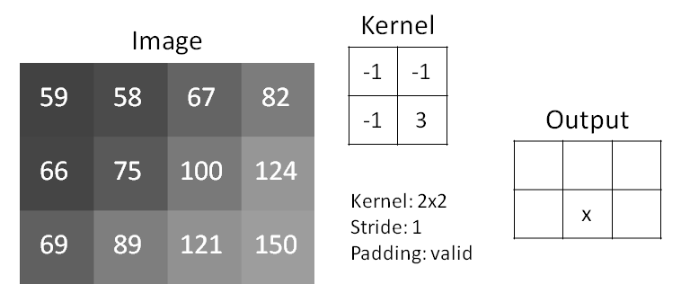

Answer: 99

Explanation: Look at the bottom middle 2x2 pixels of the input image. We convolve that with the kernel to get (-1 * 75) + (-1 * 100) + (-1 * 89) + (3 * 121) = 99.

Question

Given the following input image, a window size of 2x2, a stride of 2, and valid padding, what is the value of x in the output image if we are using maximum pooling? The output image is 2x1, and x is the second pixel to the right on the first row. Your answer should be an integer.

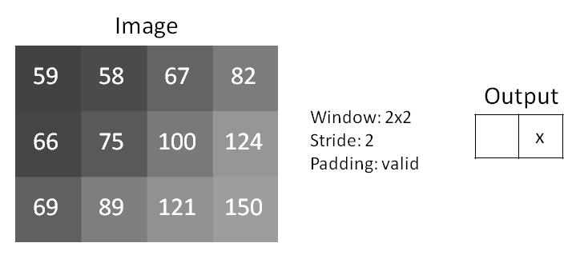

Answer: 124

Explanation: The output value for x is simply the maximum value of the top right 2x2 pixels.

Question

The feature extraction portion of a convolutional neural network filters and pools input images to create feature maps that identify salient features that are used in the decision-making process.

1. **True**
2. False

Question

If 2 feature maps are sent to a convolution layer with 4 convolution filters, how many output feature maps will there be from that layer?

Answer: 4

Explanation: The number of output feature maps is equal to the number of convolution filters.